**Name:** Harsh Chheda

**Roll Number:** 31031521005 / 22-15405

**Class:** Msc. Computer Science

**Subject**: Cloud Computing

**Year:** 2022-23

**Practical 3**

**Aim:** Demonstration of IaaS cloud

**Code:**

# To create an Azure storage account with the Azure portal, follow these steps

## From the left portal menu, select Storage accounts to display a list of your storage accounts. If the portal menu isn't visible, click the menu button to toggle it on.

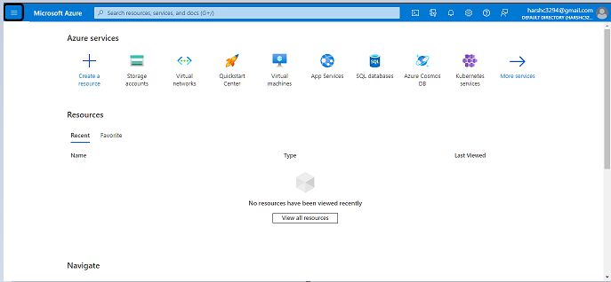

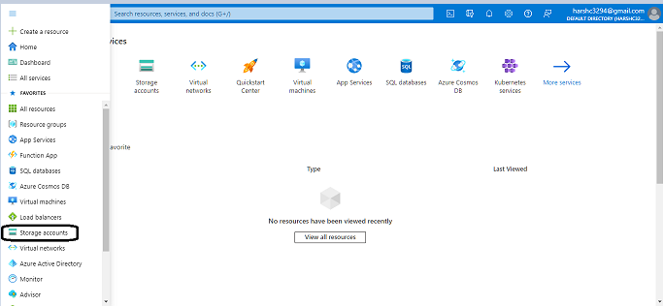

## On the **Storage accounts** page, select **Create**

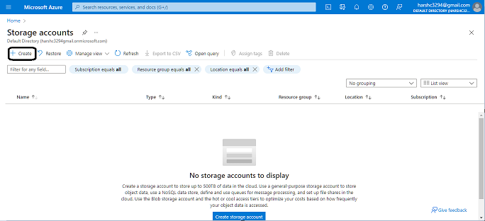

## The following image shows a standard configuration of the basic properties for a new storage account.

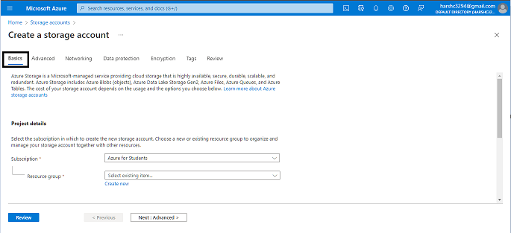

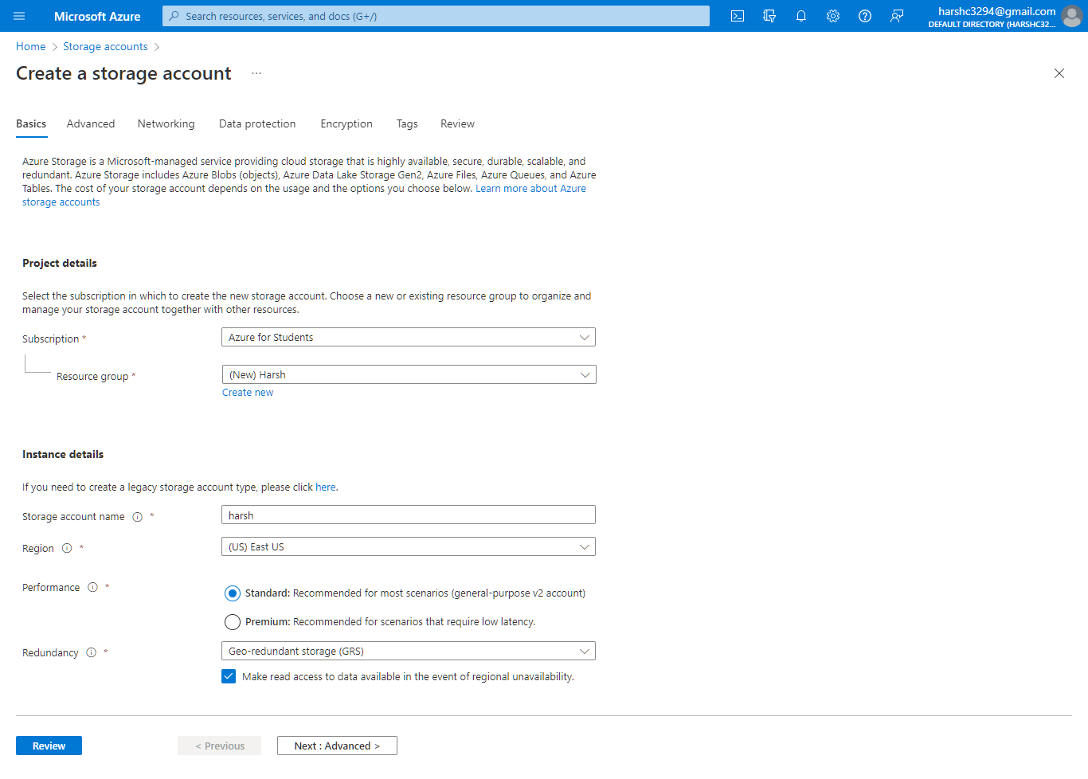

## The following image shows a standard configuration of the advanced properties for a new storage account.

